Grade 10
Unit 3
Past perfect
(Qúa khứ hoàn thành)
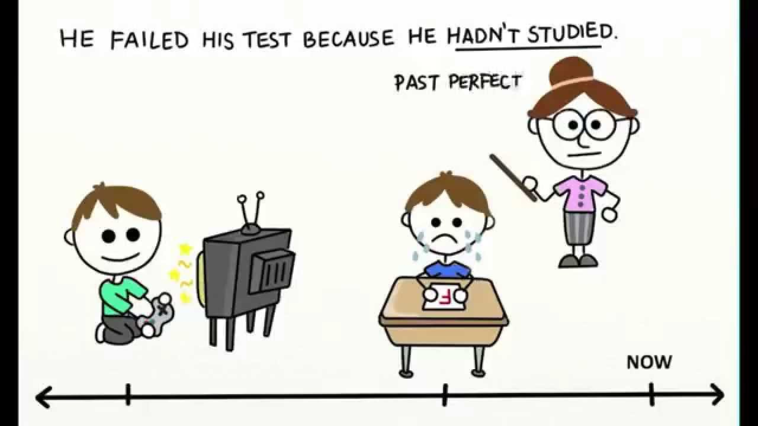
- Usage & Examples:
- Hành động xảy ra trước một thời điểm hay một hành động khác trong quá khứ.
e.g.
She had arrived at the airport before 10 o’clock yesterday.
By the time she arrived at the airport, the plane had taken off.
Yesterday, when Peter came to the party, everyone had already left.
After the plane had taken off, she arrived at the airport.
Before she arrived at the airport, the plane had taken off.
- Signal words:
by + năm ở quá khứ | up to then
By the time + S + QKĐ, S + QKHT | When + S + QKĐ, S + QKHT
Before + S + QKĐ, S + QKHT | After/ As soon as + S + QKHT, S + QKĐ

- Forms & Examples:
e.g.
I met them after they had divorced each other.
The man sitting next to me on the plane was very nervous. He hadn’t flown before.
Had the film ended when you arrived at the cinema? - Yes, it had./ No, it hadn’t.

The past perfect vs. the past simple
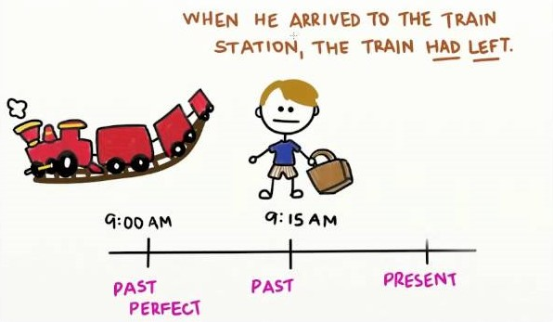
- Differences:
The past simple | The past perfect
- Diễn tả một hành động đã xảy ra tại một thời điểm xác định trong quá khứ.  e.g.  I met him yesterday.  - Diễn tả một hành động xảy ra suốt một thời gian trong quá khứ và đã chấm dứt.  e.g.  She worked for that company for 3 years. | - Diễn tả một hành động đã xảy ra trước một thời điểm xác định trong quá khứ.  e.g.  Before 2000, I had lived in Hue.  - Diễn tả một hành động đã xảy ra trước một hành động khác trong quá khứ.  e.g.  He went home after he had eaten a big roasted chicken.

Exercise 1. Put the verbs into Past Perfect.
- He (do) ____________________ nothing before he saw me.
- After they (go) ____________________, I sat down and rested.
- He died after he (be) ____________________ ill a long time.
- It rained heavily yesterday after it (be) ____________________ dry for months.
- Before you went very far, we found that we (lose) ____________________ our way.
- My friend (not see) ____________________ me for many years when I met him.
- By the time he arrived at the party, all his classmates (leave) ____________________.
- After arriving home, I realised I (buy) ____________________ any milk.
- We (not/ meet) ____________________ them before the reception yesterday.
- When we came to the stadium, the match (already, begin) ____________________.

Exercise 2. Give the correct tense, using Past Perfect or Past Simple.
- After I (have) ____________________ breakfast, I (go) ____________________ to school.
- Before it (rain) ____________________, they (watch) ____________________ TV.
- I (learn) ____________________ my lessons before I (play) ____________________ football.
- When I (open) ____________________ the bad, I realized that I (leave) ____________________ the book on the bus.
- He (drink) ____________________ tea after he (eat) ____________________ a cake.
- I (meet) ____________________ him two weeks ago.
- I (plant) ____________________ this tree last year.
- When the students (do) ____________________ the experiment, they (write) ____________________ a report on it.
- She said that she (already, see) ____________________ Dr. Rice.
- It was the first time I ( ever, see) ____________________ such a beautiful girl.

Exercise 3. Rewrite the sentences, beginning with the given words.
- When we had paid the bill, we left the restaurant.
After
- By the time she was twelve, she had already decided on a career.
Before
- I took the medicine. Then I felt a little better.
After I had
- Yesterday John went to the store. Then he went home.
Before John
- I hadn’t had breakfast when I left the house this morning.
By the time I

